Food Store
Objective:
Food Store is an online application to be built as a product that can be catering to various customers who requires purchasing foods.
Users of the System:
- Admin
- Customer
Functional Requirements:
- Build an application that customer can access and purchase Food online.
- The application should have signup, login, profile, dashboard page, and product page.
- This application should have a provision to maintain a database for customer information, order information and product portfolio.
- Also, an integrated platform required for admin and customer.
- Administration module to include options for adding / modifying / removing the existing product(s) and customer management.

While the above ones are the basic functional features expected, the below ones can be nice to have add-on features:
- Filters for products like Low to High or showcasing products based on the customer’s price range, specific brands etc.
- Email integration for intimating new personalized offers to customers.
- Multi-factor authentication for the sign-in process
- Payment Gateway

Output/ Post Condition:
- Records Persisted in Success & Failure Collections
- Standalone application / Deployed in an app Container

Non-Functional Requirements:

Security | - App Platform –UserName/Password-Based Credentials  - Sensitive data has to be categorized and stored in a secure manner  - Secure connection for transmission of any data
Performance | - Peak Load Performance (during Festival days, National holidays etc)  - eCommerce -< 3 Sec  - Admin application < 2 Sec  - Non Peak Load Performance  - eCommerce < 2 Sec  - Admin Application < 2 Sec
Availability | - 99.99 % Availability
Standard Features | - Scalability  - Maintainability  - Usability  - Availability  - Failover
Logging & Auditing | - The system should support logging(app/web/DB) & auditing at all levels
Monitoring | - Should be able to monitor via as-is enterprise monitoring tools
Cloud | - The Solution should be made Cloud-ready and should have a minimum impact when moving away to Cloud infrastructure
Browser Compatible | - IE 7+  - Mozilla Firefox Latest – 15  - Google Chrome Latest – 20  - Mobile Ready

Technology Stack
Front End | Angular 7+  Bootstrap / Bulma
Server Side | Spring Boot  Spring Web (Rest Controller)  Spring Security  Spring AOP  Spring Hibernate
Core Platform | OpenJDK 11
Database | MySQL or H2

Platform Pre-requisites (Do’s and Don’ts):
- The angular app should run in port 8081. Do not run the angular app in the port: 4200.
- Spring boot app should run in port 8080.

Key points to remember:
- The id (for frontend) and attributes(backend) mentioned in the SRS should not be modified at any cost. Failing to do may fail test cases.
- Remember to check the screenshots provided with the SRS. Strictly adhere to id mapping and attribute mapping. Failing to do may fail test cases.
- Strictly adhere to the proper project scaffolding (Folder structure), coding conventions, method definitions and return types.
- Adhere strictly to the endpoints given below.

Application assumptions:
- The login page should be the first page rendered when the application loads.
- Manual routing should be restricted by using AuthGaurd by implementing the canActivate interface. For example, if the user enters as http://localhost:4200/signup or http://localhost:4200/home the page should not navigate to the corresponding page instead it should redirect to the login page.
- Unless logged into the system, the user cannot navigate to any other pages.
- Logging out must again redirect to the login page.
- To navigate to the admin side, you can store a user type as admin in the database with a username and password as admin.
- Use admin/admin as the username and password to navigate to the admin dashboard.

Validations:
- Basic email validation should be performed.
- Basic mobile validation should be performed.
Project Tasks:
API Endpoints:
USER
Action | URL | Method | Response
Login | /login | POST | true/false
Signup | /signup | POST | true/false
Get All Products – Home | /home | GET | Array of Products
Add to cart | /home/{id} | POST | Item added to cart
Cart Items | /cart/{id} | GET | Array of Cart Items
Delete cart Item | /cart/delete | POST | Cart Deleted
Cart to Orders | /saveOrder | POST | Cart items added to the Orders list
Orders list | /orders | POST | Array of Orders
Place order directly | /placeOrder | POST | Place items to orders directly
ADMIN
Action | URL | Method | Response
Get All Products | /admin | GET | Array of Products
Add Product | /admin/addProduct | POST | Product added
Delete Product | /admin/delete/{id} | GET | Product deleted
Product Edit | /admin/productEdit/{id} | GET | Get All details of Particular id
Product Edit | /admin/productEdit/{id} | POST | Save the Changes
Get All Orders | /admin/orders | GET | Array of Orders
Frontend:
Customer:
Signup:
Output screenshot:
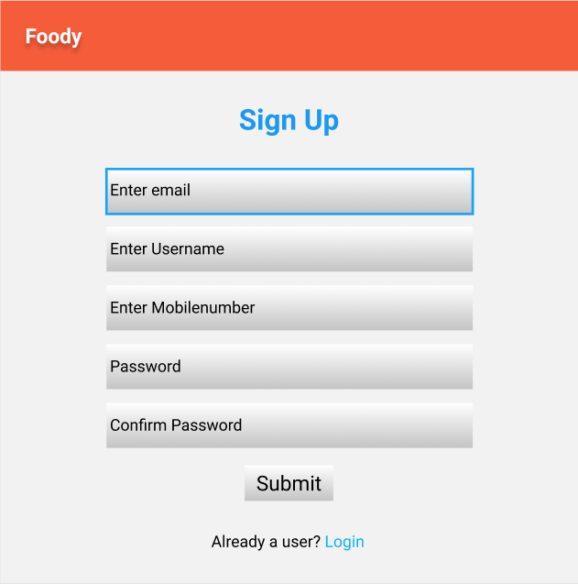
Login:
Output Screenshot:
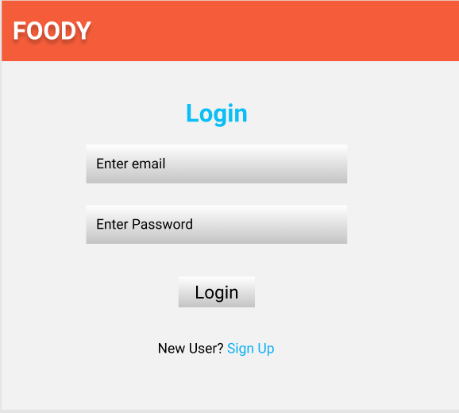
Home:
Output Screenshot:
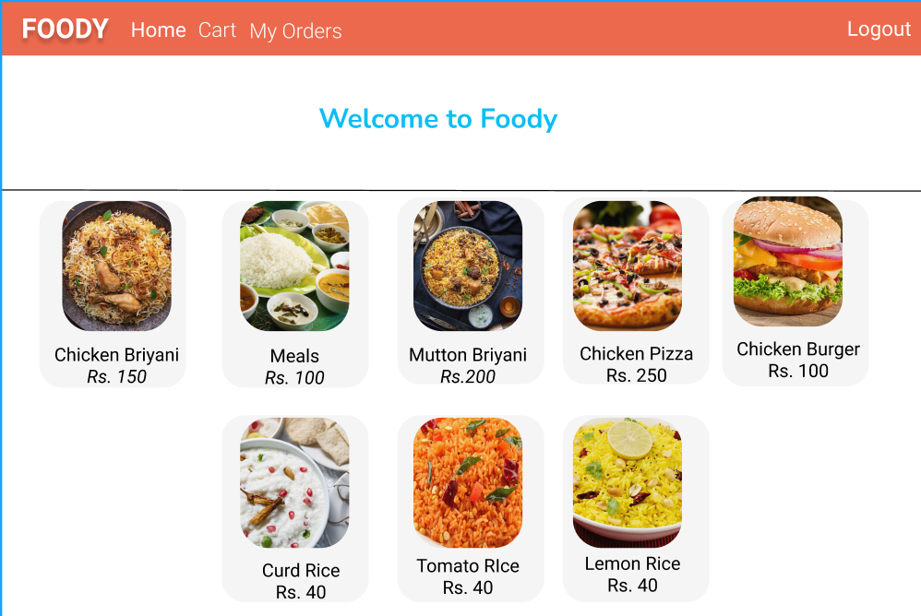

Cart:
Output Screenshot:
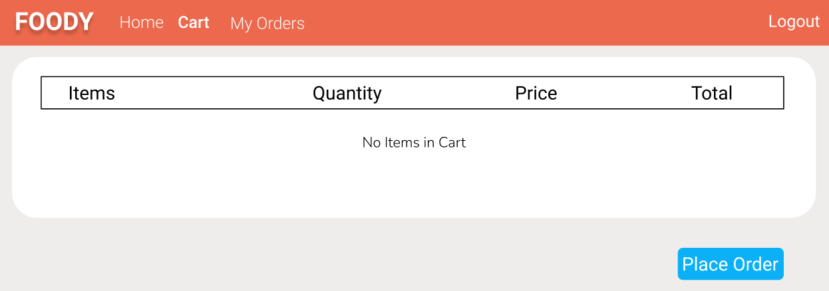

My Orders:
Output Screenshot:
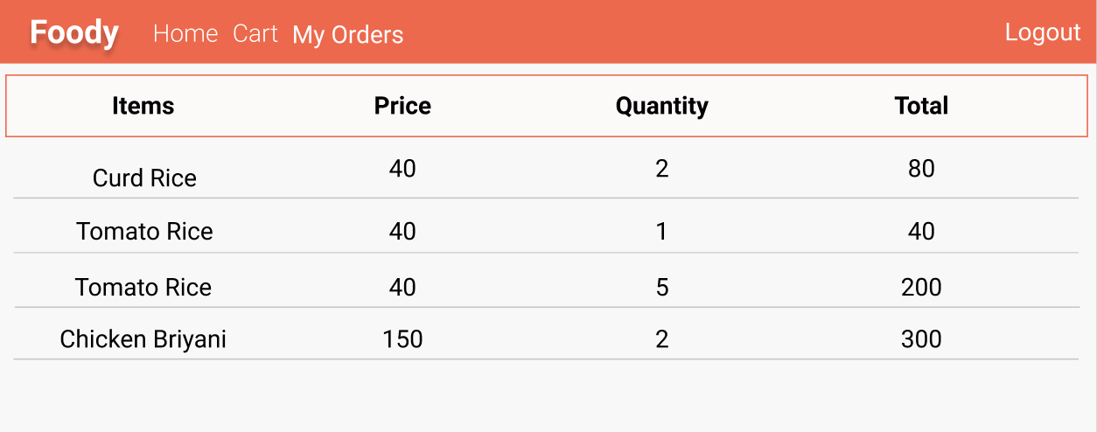

Admin:
Home:
Output Screenshot:
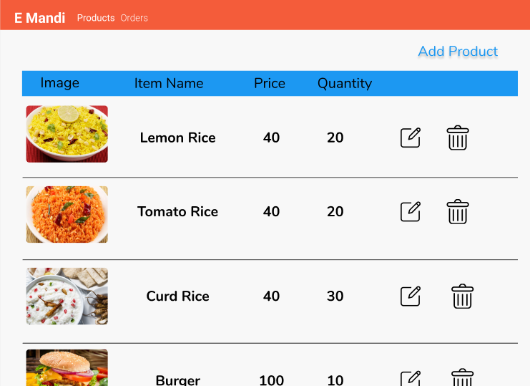

Add Product:
Use popup box to get the values.
Output Screenshot:
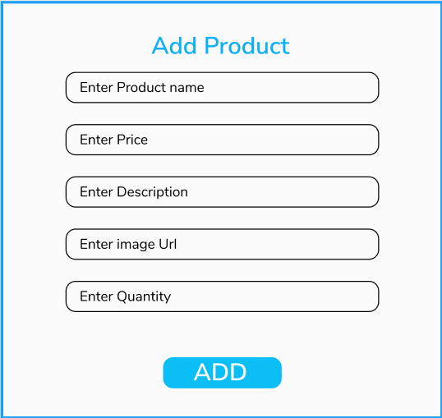

View Orders:
Output Screenshot
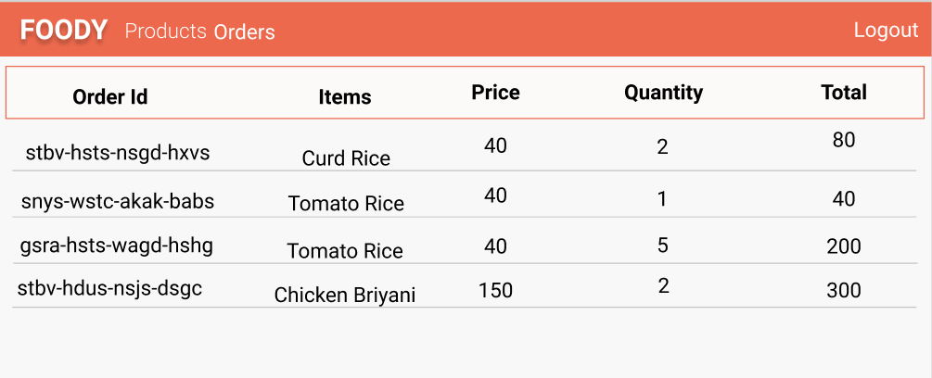

Backend:
Class and Method description:

Model Layer:

- UserModel: This class stores the user type (admin or the customer) and all user information.
  - Attributes:
    - email: String
    - password: String
    - username: String
    - mobileNumber: String
    - active: Boolean
    - role: String
    - cart: CartModel
    - ordersList: List<OrderModel>
  - Methods: -
- LoginModel: This class contains the email and password of the user.
  - Attributes:
    - email: String
    - password: String
  - Methods: -
- ProductModel: This class stores the details of the product.
  - Attributes:
    - productId: String
    - imageUrl: String
    - productName: String
    - price: String
    - description: String
    - quantity: String
  - Methods: -
- CartModel: This class stores the cart items.
  - Attributes:
    - cartItemID: String
    - userId: UserModel
    - ProductName: String
    - Quantity: int
    - Price: String
  - Methods: -
- OrderModel: This class stores the order details.
  - Attributes:
    - orderId: String
    - userId: String
    - ProductName: String
    - quantity: int
    - totalPrice: String
    - Status: String
    - Price: String
  - Methods: -
Controller Layer:
- SignupController: This class control the user signup
  - Attributes: -
  - Methods:
    - saveUser(UserModel user): This method helps to store users in the database and return true or false based on the database transaction.
- LoginController: This class controls the user login.
  - Attributes: -
  - Methods:
    - checkUser(LoginModel data): This method helps the user to sign up for the application and must return true or false
- ProductController: This class controls the add/edit/update/view products.
  - Attributes: -
  - Methods:
    - List<ProductModel> getProduct(): This method helps the admin to fetch all products from the database.
    - List<ProductModel> getHomeProduct(): This method helps to retrieve all the products from the database.
    - ProductModel productEditData(String id): This method helps to retrieve a product from the database based on the productid.
    - productEditSave(ProductModel data): This method helps to edit a product and save it to the database.
    - productSave(ProductModel data): This method helps to add a new product to the database.
    - productDelete String id): This method helps to delete a product from the database.
- CartController: This class helps in adding product to the cart, deleting the products from the cart, updating items in the cart.
  - Attributes: -
  - Methods:
    - addToCart(String Quantity, String id): This method helps the customer to add the product to the cart.
    - List<CartTempModel> showCart(String id): This method helps to view the cart items.
    - deleteCartItem(String id): This method helps to delete a product from the cart.
- OrderController: This class helps with the orders such as save order/ place an order/ view order.
  - Attributes: -
  - Methods:
    - List<OrderTemp> getUserProducts(String id): This method helps to list the orders based on the user id.
    - saveProduct(String id): This method helps to save the cart items as an order.
    - placeOrder(OrderModel order): This method helps to place an order by the customer.

